Azure DataBricks:
Azure Databricks is a fast, easy, and collaborative Apache Spark-based data and AI platform optimized for Microsoft Azure. It provides a unified environment for big data and AI workloads, combining the best of Databricks and Azure to simplify data engineering, data science, and machine learning.

Azure Databricks is a cloud-based unified analytics platform designed to simplify and accelerate data engineering, data science, machine learning, and analytics workflows. Built on Apache Spark, it integrates seamlessly with Microsoft Azure services, enabling organizations to process, analyze, and visualize large datasets efficiently.

Azure Databricks provides a data lakehouse architecture, combining the scalability of data lakes with the performance of data warehouses. This architecture supports diverse workloads, including ETL (Extract, Transform, Load), real-time streaming, machine learning, and business intelligence.

Key Features
- Unified Workspace: Offers a collaborative environment for data engineers, data scientists, and analysts to work together using notebooks that support Python, R, Scala, and SQL.
- Scalability and Flexibility: Automatically scales compute resources to handle workloads of varying sizes, from batch processing to real-time streaming.
- Integration with Azure Services: Connects easily with Azure Data Lake, Power BI, Azure Machine Learning, and Azure OpenAI for seamless workflows.
- Delta Lake: Provides an optimized storage layer with ACID transactions, data versioning, and time travel capabilities for reliable data management.
- Machine Learning and AI: Includes tools like MLflow and libraries such as Hugging Face Transformers for building, training, and deploying machine learning models.
- Data Governance: Features Unity Catalog for centralized data governance, ensuring secure and compliant data sharing within and outside the organization.
Common Use Cases
- Data Engineering and ETL: Automates data pipelines with tools like Auto Loader and Lakeflow Declarative Pipelines for efficient data ingestion and transformation.
- Machine Learning and AI: Enables training and deployment of machine learning models using pre-built libraries and integration with OpenAI models.
- Real-Time Analytics: Processes streaming data using Apache Spark Structured Streaming, ideal for applications like IoT and fraud detection.
- Business Intelligence: Supports SQL-based queries and visualizations, making it easy for analysts to derive insights from data.
- Data Warehousing: Combines data lakes and warehouses for fast, scalable analytics without data silos.

It is commonly used for tasks such as data preparation, real-time analysis, and machine learning. Some examples of how Databricks might be used include:
- Processing large amounts of data from multiple sources, such as web logs, sensor data, or transactional data, in order to gain insights and identify trends.
- Building and training machine learning models, using tools such as TensorFlow, Keras, and PyTorch, to make predictions or perform other types of data analysis.
- Real-time data analysis, such as monitoring and analyzing streaming data from sensors or other sources, in order to make timely decisions or take action based on the data.
- Data preparation, such as cleaning, transforming, and enriching data, in order to make it ready for analysis or other uses.
Overall, Databricks is a versatile platform that can be used for a wide range of data-related tasks, from simple data preparation and analysis to complex machine learning and real-time data processing.
Some common Use Cases for Databricks:
- Data Warehousing: Databricks can be used to store and manage large amounts of data from multiple sources, and provide fast and efficient access to the data for analysis and other purposes.
- Data Preparation: Databricks provides tools and services for cleaning, transforming, and enriching data, making it easier to prepare data for analysis or other uses.
- Data Analysis: Databricks offers a range of tools and services for exploring, visualizing, and analyzing data, so that users can gain insights and identify trends in the data.
- Machine Learning: Databricks supports popular machine learning libraries and frameworks, such as TensorFlow, Keras, and PyTorch, making it easier to build and train machine learning models on large datasets.
- Real-time Data Processing: Databricks can be used to process streaming data in real-time so that users can take action based on the data as it arrives.

Terminologies related to Databricks
- Cluster: a set of compute resources (e.g., virtual machines or containers) that are used to execute tasks in Databricks.
- Notebook: a web-based interface for interacting with a Databricks cluster. Notebooks allow you to write and run code, as well as document your work using markdown and rich media.
- Spark: an open-source data processing engine used by Databricks to perform distributed data processing tasks.
- Delta Lake: an open-source storage layer that sits on top of cloud storage (e.g., S3 or Azure Blob Storage) and adds ACID transactions, data versioning, and time travel capabilities to Spark.
- Workspace: a web-based interface for organizing and collaborating on Databricks projects.
- Jobs: a way to automate notebook or Python code execution on a schedule or on a trigger (e.g., the arrival of new data).
- Libraries: pre-packaged code that can be imported into notebooks or jobs to perform common tasks (e.g., reading from a database or performing machine learning).
- Autoscaling: a feature that allows Databricks clusters to automatically scale up or down based on workload demands.
- Security: Databricks provides a number of security features to help protect data and control access to resources, including encryption, authentication, and role-based access control.

Advantages of Data Bricks:

Databricks offers a unified platform that simplifies the data lifecycle, enhances collaboration, and integrates advanced analytics and AI capabilities, making it a powerful tool for organizations.

- Unified Data Platform: Databricks combines data engineering, machine learning, and business intelligence into a single collaborative environment. This integration allows teams to work seamlessly across different stages of the data lifecycle, from ingestion and transformation to modeling and visualization datafram.com.
- Lakehouse Architecture: The platform employs a Lakehouse architecture that merges the benefits of data lakes and data warehouses. This model supports structured, semi-structured, and unstructured data, enabling organizations to handle diverse data types without compromising performance or flexibility datafram.com.
- Scalability and Flexibility: Databricks is cloud-native, allowing organizations to scale compute and storage resources independently. This pay-as-you-go model provides flexibility and cost efficiency, adapting to varying workloads and data processing needs datafram.com.
- Collaboration and Productivity: With shared interactive notebooks, cross-functional teams can collaborate effectively, fostering transparency and efficiency in data projects. This collaborative approach enhances productivity and accelerates time-to-insight datafram.com+1.
- Advanced Analytics and AI Integration: Databricks facilitates the development of AI applications and advanced analytics. It provides tools for data quality, lineage, and governance, ensuring that organizations can maintain control over their data while leveraging it for AI-driven insights Databricks.
- Open-Source Friendly: The platform supports open formats and libraries, reducing vendor lock-in and allowing organizations to utilize a wide range of tools and technologies datafram.com.
- Improved Performance: Organizations can achieve significantly better price/performance ratios for SQL and BI workloads by transitioning from traditional data warehouses to Databricks' Lakehouse model, which is optimized for both batch and real-time processing Databricks.

What is Workspace in Databricks?

A Databricks workspace is a shared environment where you can collaborate with others on various tasks related to data engineering, data science, machine learning, and more.
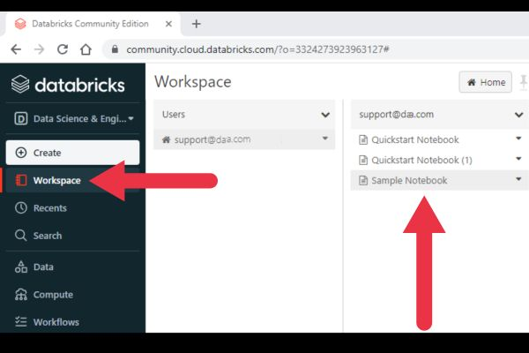

- Inside a workspace
Notebooks, Jobs, Clusters, Libraries ,Repos, Models

Workspace Vs Clusters

Workspaces and clusters play key roles in a Databricks set-up, but they are fundamentally different and serve unique purposes.
A workspace is the shared environment where users carry out their tasks using assets like notebooks, libraries, jobs, and data.
Clusters are sets of computational resources where the actual data processing occurs. In Databricks, a cluster is a distributed computing system made up of a driver node and worker nodes that process your data and execute your commands.

Exploratory Data Analysis
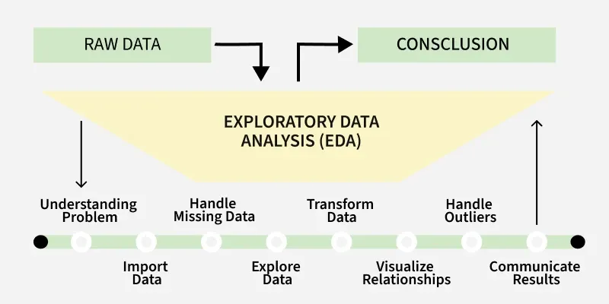

Exploratory Data Analysis (EDA) is an important step in data analysis where we explore, summarize, and visualize data to understand its structure, detect patterns, identify anomalies, test assumptions, and check relationships between variables before applying any machine learning or statistical models.

Types of Exploratory Data Analysis

1. Univariate Analysis
Univariate analysis studies one variable at a time to understand its characteristics and distribution.
- Histograms: Show how data values are distributed.
- Box plots: Help detect outliers and show data spread.
- Bar charts: Used for categorical variables.

2. Bivariate Analysis
Bivariate analysis examines the relationship between two variables to understand how they interact or influence each other. Common techniques include:

- Scatter plots: Show the relationship between two numerical variables.
- Correlation coefficient: Measures the strength of the relationship between variables .
- Cross-tabulation: Displays the relationship between two categorical variables.
- Line graphs: Compare two variables over time to identify trends.
- Covariance: Shows how two variables change together.

3. Multivariate Analysis
Multivariate analysis studies three or more variables together to understand complex relationships within the dataset. Common techniques include:
- Pair plots: Show relationships between multiple variables at once.
- Principal Component Analysis (PCA): Reduces dimensionality while preserving important information.
- Spatial analysis: Analyzes geographical patterns using maps and location-based data.

Steps in EDA:
